* Deploy an image from dockerhub like nginx with 3 replicas
* Deploy a kubernetes Load Balancer service type in conjunction with the Kubernetes services to ensure the efficient distribution of network traffic.
* Deploy Pod autoscale using HPA to ensure the automatic scaling of pods based on CPU utilization of 80% and above with min:3 Pods and max : 10 pods configuration or other specified metrics.

Deployment yaml file code screenshot

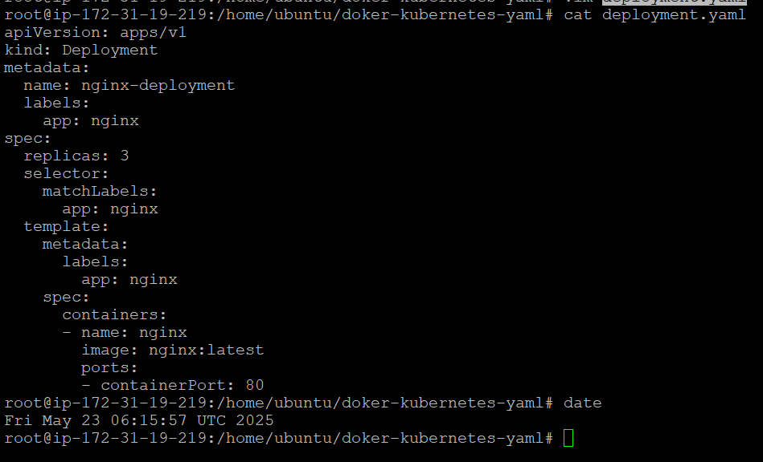

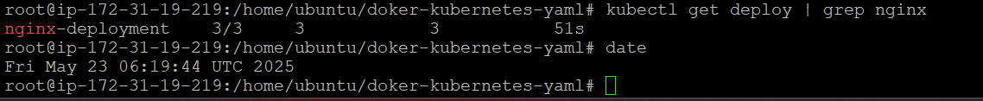

service yaml file content screenshot

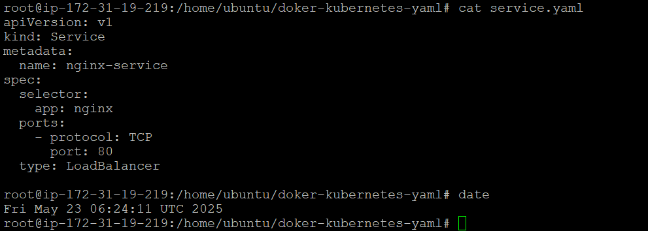

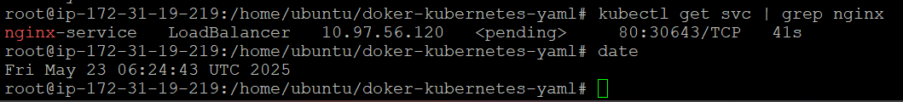

autocaling yaml fiel content screenshot

